TSM UPGRADE
&
BASIC TROUBLESHOOTING

Step 1
Check for the current tsm tiv version on the server with below command
rpm -qa --last|grep -i tiv
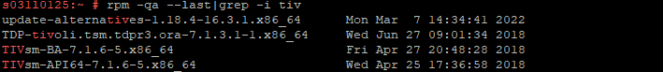
Then go to below path
/opt/tivoli/tsm/client/ba/bin
And take backup of dsm.sys and dsm.opt

Check path for TSM.PWD file from dsm.sys file , go to the path and take backup of TSM.PWD file

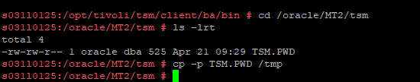

Go to below path and check for the ownership of files and change it oracle and oinstall.
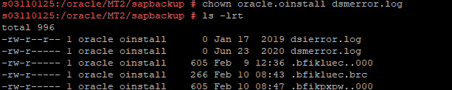

Path(here) - cd /oracle/MT2/sapprof/
Take backup of below files

Run below cmd to remove the older tiv version.

/usr/local/rwe/bin/tsm-al-baclient-remove

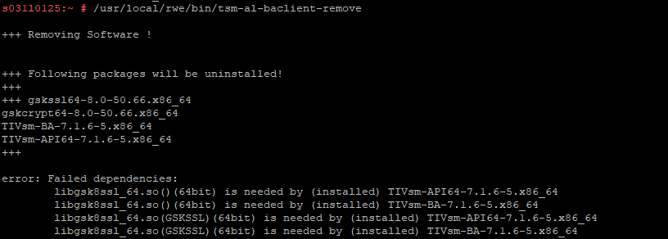

Run below cmd to remove gsk filesets
rpm -qa –last|grep -i gsk
rpm -ev gskfilesets-name

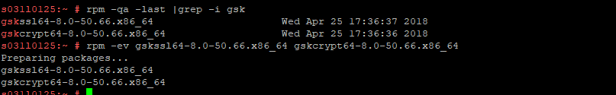

Run below cmd to install new version of TIV
/usr/local/rwe/bin/tsm-al-baclient-install -v v8.1.13.3

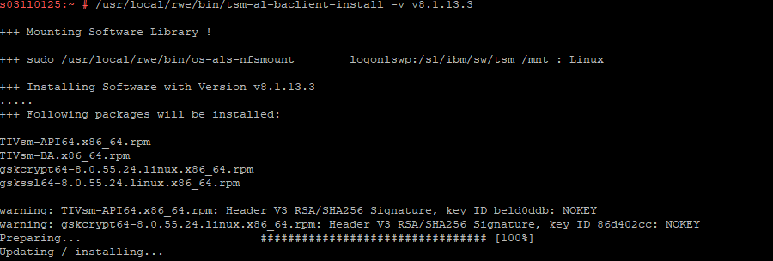

Check for newer version
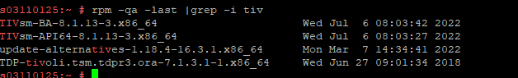

Run below command to update tdpr3 filesets
/usr/local/rwe/bin/tsm-al-tdpr3-install -v v8.1.9.1 -s MT2(instance name as per server) -u

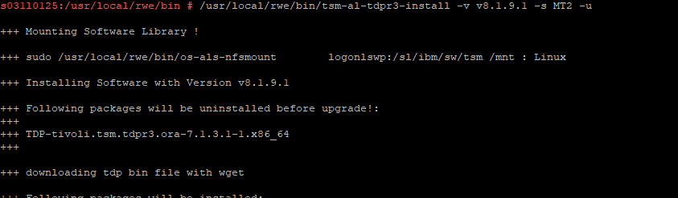

Now check with dsmc command for proper connection

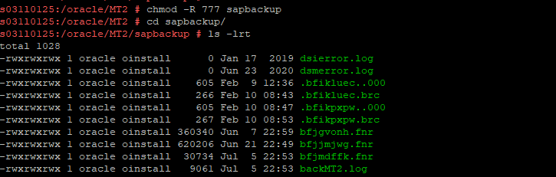
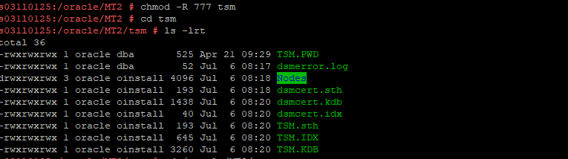

Switch to oracle user and run below cmd
/opt/tivoli/tsm/tdp_r3/ora64/backint -p /oracle/EP3/sapprof/initEP3.utl.medium -f password
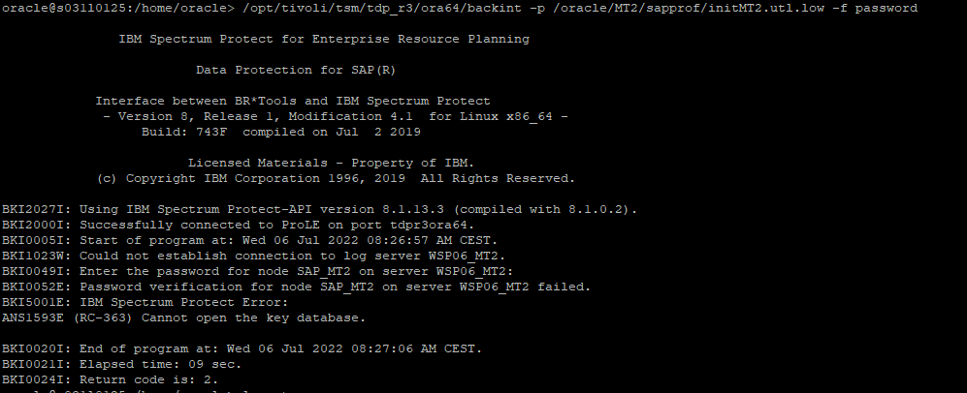

Note :- Modify the permissions for previously checked directories like /oracle/MT2/sapbackup , /oracle/MT2/sapprof if the return code is not 0

THANK
YOU

